Name : Evan Diantha Fafian

Class : SIB 2G

Absent : 09

NIM : 2341760163

|  |  |
| --- | --- |
|  | Department of Description Technology, Malang State Polytechnic  **Jobsheet-7: PHP - Form Proccessing**  **Web Design and Programming Courses**  Tutor: Web Design and Programming Teaching Team  *October 2023* |

**Topic**

* The Concept of Form Proccessing with PHP and Jquery

**Purpose**

Students are expected to:

1. Students are able to create forms using PHP
2. Students are able to create forms using jQuery

**Attention**

This jobsheet must be done step-by-step according to the Practical Section steps that have been given. Questions can be answered directly in the column provided using the PDF Editor.

**Introduction**

**Function isset**

**isset()** is a function in PHP that is used to check whether a variable has been defined (exists) or not. This function returns **true** if the variable has been defined and has a value, and false if the variable does not exist or has a null value. Here's an example script and a minimal explanation of isset()**:**

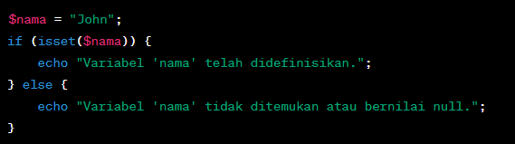

The above code checks if $nama variable has been defined. If yes, then the message "Variable 'name' has been defined." will be displayed, if not, then the message "Variable 'name' not found or null value." will be displayed.

**Practical Section 1. Function isset()**

|  |  |
| --- | --- |
| **Step** | **Description** |
| 1 | Create a new folder JS07_PHP-jQuery in dasarWeb and name it isset.php |
| 2 | Type into the isset.php file the code below. |
| 3 |  |
| 4 | Save the file, then open a browser and run localhost/dasarWeb/JS07_PHP-jQuery/isset.php. What do you understand from using the isset on the file. Give me your answer.  (Question No 1.1)     * from the code will pop up a “Anda belum dewasa atau variabel 'umur' tidak ditemukan.” message because the $umur variable has not been assigned a value or the $umur variable is not found |
| 5 | Add the contents of the isset.php file with the code below. |
| 6 | Save the file, then open the browser and run localhost/dasarWeb/JS07_PHP-jQuery/isset.php. Ensure that the output does not appear in a single line; the result from the echo should be displayed separately. Explain what you understand from the use of isset() in that file. Write your understanding below. (Question No 1.2)     * name will be printed because the array found the variable 'nama' |

**Function** empty()

The empty() function in PHP is used to check whether a variable is empty or undefined. This function returns true if the variable is empty or undefined, and false if the variable has a value or has been defined. Here is an explanation and example of using empty()**:**

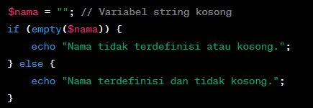

The empty() function can be used to check whether a string is empty or not.

**Practical Section 2. Function** empty()

|  |  |
| --- | --- |
| **Step** | **Description** |
| 1 | Create a new file named empty.php inside JS07_PHP-jQuery folder. Write this code into empty.php file |
| 2 |  |
| 3 | Save the file, then open a browser and run localhost/dasarWeb/JS07_PHP-jQuery/empty.php  What do you understand from the use of empty on the file. Write your understanding below. (Question No 2.1)     * because the array is empty, the message “Array tidak terdefinisi atau kosong.” will be printed, or in other words, the empty() function is used to check whether the variable, array, etc. is empty or not. |
| 4 | Add the contents of the empty.php file with the code below |
| 5 | Save the file, then open the browser and run localhost/dasarWeb/JS07_PHP-jQuery/empty.php. Ensure that the output does not appear in a single line; the result from the echo should be displayed separately. Explain what you understand from the use of empty() in that file. Write your understanding below. (Question No 2.2)     * is the same as the previous one because the array is not defined it will print the message “Array tidak terdefinisi atau kosong.” |

**Practical Section Part 3: PHP Input Form**

|  |  |
| --- | --- |
| **Step** | **Description** |
| 1 | Create a new file named form.php inside JS07_PHP-jQuery folder. Write this code below |
| 2 |  |
| 3 | Create a new file named form_process.php inside JS07_PHP-jQuery folder Type the code in step 2 inside the form_process.php |
| 4 | Save the file, then open a browser and run localhost/dasarWeb/JS07_PHP-jQuery/form_process.php. What do you understand from the use of forms in the file. Write your understanding below. (Question No. 3.1)     * the html section is used to create an input form and then the php section is used to process the data sent from the form. |
| 5 | Create a new file named form_self.php inside JS07_PHP-jQuery folder Type the code below inside form_self.php |
| 6 | Save the file, then open a browser and run localhost/dasarWeb/JS07_PHP-jQuery/ form_self.php. What do you understand from the use of forms in the file. Write your understanding below. (Question No 3.2)     * The same as the above, the html section is used to create a form and then the php section is used to process input data from the form, but this time it has a slight difference because the php section is also used to store data after processing. |

**HTML Injection**

HTML injection (also known as an "HTML injection attack" or "client-side injection") is a security attack that occurs when an attacker injects malicious HTML or JavaScript code into the input received by a web application. The malicious code will be executed by the user's browser viewing the affected web page, which could result in illegal access to data, changes in page view, or other attacks.

An attacker can try to inject malicious HTML or JavaScript code into the input received by the web application. If the web application does not properly sanitize or escape input, then the malicious code will be executed by the user's browser, which can cause security issues.

**Example HTML Injection:**

For example, we have a simple search form on a website that searches for keywords among user reviews:

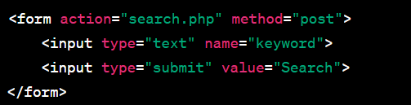

Now, if a web application doesn't validate the input correctly, an attacker can enter malicious input like this:



If the web application does not avoid or clean up this input before displaying it on the search results page, then the result will look like this:



The malicious JavaScript code will be executed by the user's browser and will bring up a "You have been hacked!" warning box. This is a simple example of HTML injection. As a web developer, it is important to always sanitize and validate input from users, as well as avoid displaying user input directly on web pages without proper escaping or sanitation to avoid these kinds of attacks.

**How to Handle HTML Injection**

The way to handle HTML injection is to validate, filter, and avoid displaying user input without proper escaping. Here are some steps to protect your app from HTML injection:

1. **Input Validation**: Validate input from users to ensure that only valid data is received. You can use functions such as filter_input() or filter_var() to perform validation.
2. **Filter Input**: Filter user input to remove or replace potentially harmful characters, such as **<**, **>**, **&**, and more. You can use functions like htmlspecialchars() or strip_tags() for this.
3. **Parameterized Statements (Query):** If you generate SQL queries with user input, use parameterized statements or prepared statements to prevent SQL injection, which can be a form of attack similar to HTML injection.
4. **Content Security Policy (CSP):** Apply a Content Security Policy (CSP) to your HTTP headers to control the resources that can be used within your web pages.
5. **Escape Output**: When you display data on a web page, make sure you avoid JavaScript injection by using htmlspecialchars() or similar methods.

Here's a simple example in PHP to solve HTML injection:

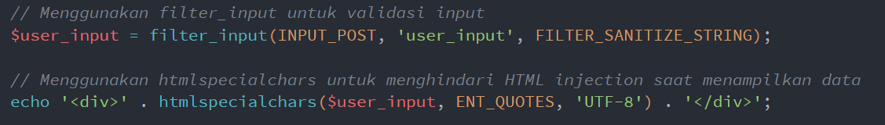

By using these steps, you can mitigate the risk of HTML injection in your web application. It's always important to validate inputs, clean incoming data, and avoid displaying user data without proper escaping.

**Practical Section 4 : HTML Injection**

Practical Section Steps:

|  |  |
| --- | --- |
| **Step** | **Description** |
| 1 | Create a new file named html_safe.php inside JS07_PHP-jQuery folder. Type the code below inside html_safe.php |
| 2 |  |
| 3 | Add another script so that step 2 can run normally, save the file. Then open a browser and run localhost/dasarWeb/JS07_PHP-jQuery/html_safe.php |
| 4 | Note here what you observe from the addition of the program code above. (Question No. 4.1)     * The code is an example of using the htmlspecialchars function to secure user input from XSS (Cross-Site Scripting) attacks. |
| 5 | Type the additional code in step 6 inside the html_safe.php |
| 6 |  |
| 7 | Complete the program code above so that the result is neat. Save the file, then open a browser and run /refresh localhost/dasarWeb/JS07_PHP-jQuery/html_safe.php |
| 8 | Note here what you observe from the addition of the program code above. (Question No. 4.2)     * The code is an example of using the filter_var function to check if the user input is a valid email. |

**Regular Expression (Regex)**

Regex is a powerful tool for searching, matching, or manipulating text based on specific patterns. You can use it for various purposes such as input validation, text search, text replacement, and more.

**Basic Regex Patterns:**

* **Single Character**: Any character will match itself in Regex, except for special characters that must be avoided with escape characters.
  + Example: The **/a/** pattern will match the letter "a" in the text.
* **Specific Characters**: You can match specific characters by mentioning them in a pattern.
  + Example: **The /hello/** pattern will match the text "hello" in the text.
* **Special Characters**: Some special characters in Regex should be avoided with escape characters (**\**) if you want to match them literally. Examples of special characters: ., *, +, ?, |, [, ], (, ) , {, }, ^, $, \.
* **Character Set**: You can match characters from a set of characters by using [ ]. For example, /[aeiou]/ will match one of the vowels.
* **Character Range**: You can use **-** in a character set to specify a character range. For example, /[a-z]/ will match any lowercase letters.
* **Quantifier**: You can set the number of times a character or group of characters should appear beforehand. Example quantifier:
  + *: 0 or more
  + +: 1 or more
  + ?: 0 or 1 time
  + {n}: Exactly n times
  + {n,}: At least n times
  + {n,m}: At least n times, maximum m times

**Examples of Regex Usage:**

1. Matching patterns

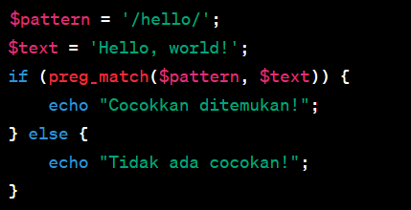

1. Match set characters

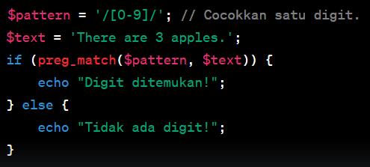

**Practical Section 5 : The Use of Regex in PHP**

Practical Section Steps:

|  |  |
| --- | --- |
| **Step** | **Description** |
| 1 | Create a new file named regex.php inside JS07_PHP-jQuery folder Type the code in step 2 inside the regex.php |
| 2 |  |
| 3 | Save the file, then open a browser and run /refresh localhost/dasarWeb/JS07_PHP-jQuery/ regex.php |
| 4 | Note here what you observe from the addition of the program code above. (Question No 5.1)     * The code is an example of using the preg_match function to match lowercase patterns in a text. |
| 5 | Type the additional code in step 6 inside the regex.php |
| 6 |  |
| 7 | Complete the program code above so that the result is neat. Save the file, then open a browser and run /refresh localhost/dasarWeb/JS07_PHP-jQuery/regex.php |
| 8 | Note here what you observe from the addition of the program code above. (Question No. 5.2)     * The code is an example of using the preg_match function to match one or more digits in a text. |
| 9 | Type the additional code in step 10 inside the regex.php |
| 10 |  |
| 11 | Complete the program code above so that the result is neat. Save the file, then open a browser and run /refresh localhost/dasarWeb/JS07_PHP-jQuery/regex.php |
| 12 | Note here what you observe from the addition of the program code above. (Question No 5.3)     * The code is an example of using the preg_replace function to replace text that matches the regex pattern. |
| 13 | Type the additional code in step 14 inside the regex.php |
| 14 |  |
| 15 | Complete the program code above so that the result is neat. Save the file, then open a browser and run /refresh localhost/dasarWeb/JS07_PHP-jQuery/regex.php |
| 16 | Note here what you observe from the addition of the program code above. (Question No 5.4)     * The code is an example of using the preg_match function to match text containing the character “go” followed by one or more characters “o” and ending with the character “d”. |
| 17 | Question 5.5: Create a script for step 14 with a variable pattern modified using '?' (0 or 1 time). Note here what you observe from the addition of the program code above. (Question No 5.5) |
| 18 | Question 5.6: Create a script for step 14 with a variable pattern modified using '{n,m}'. Note here what you observe from the addition of the program code above. (Question No 5.6) |

**Practical Section 6 : Advanced Form**

Practical Section Steps:

|  |  |
| --- | --- |
| **Step** | **Description** |
| 1 | Create a new file named form_next.php inside JS07_PHP-jQuery folder site. Type the code in step 2 inside the form_next.php |
| 2 |  |
| 3 | Save the file, then open a browser and run /refresh localhost/dasarWeb/JS07_PHP-jQuery/ form_next.php |
| 4 | Note here what you observe from the addition of the program code above. (Question No 6.1)     * This code is an example of using an HTML form with PHP to process data submitted by the user, including selecting fruit, favorite color, and gender, and displaying the results. |
| 5 | Create a new file named form_ajax.php inside JS07_PHP-jQuery folder Type the code in step 2 inside the form_ajax.php |
| 6 | Save the file, then open a browser and run /refresh localhost/dasarWeb/JS07_PHP-jQuery/form_ajax.php. Note here what you observe from the addition of the program code above. (Question No. 6.2)     * This code is an example of using an HTML form with PHP and jQuery to process data submitted by the user, including selecting fruit, favorite color and gender, and displaying the results using AJAX. |

**Practical Section 7 : Form Validation**

Practical Section Steps:

|  |  |
| --- | --- |
| **Step** | **Description** |
| 1 | Create a new file named form_validation.php inside JS07_PHP-jQuery folder Type the code below inside form_validation.php |
| 2 |  |
| 3 | Save the file, then open a browser and run /refresh localhost/dasarWeb/JS07_PHP-jQuery/form_validation.php |
| 4 | Note here what you observe from the addition of the program code above. (Question No 7.1)     * This code is an example of using HTML forms with PHP to process data sent by users, including validating names and emails before processing data. |
| 5 | Develop a file named form_validation.php inside JS07_PHP-jQuery folder site. Type the code in step 6 inside the form_validation.php |
| 6 |  |
| 7 | Save the file, then open a browser and run /refresh localhost/dasarWeb/JS07_PHP-jQuery/form_validation.php |
| 8 | Note here what you observe from the addition of the program code above. (Question No. 7.2)     * This code is an example of using an HTML form with PHP and jQuery to process data sent by the user, including real-time name and email validation using jQuery and server-side validation using PHP. |
| 9 | Question 7.3: Create a script for step 6 using ajax. Note here what you observe from the addition of the program code above. (Question No. 7.3) |
| 10 | Question 7.4: Add validation for the password with a minimum of 8 characters using jQuery and PHP added in step 9. Note here what you observe from the addition of the program code above. (Question No 7.4) |